Docker Compose

## Install Docker

## Install Docker Compose

## Restart Docker

## Stop Docker

systemctl stop docker

## Start Docker

systemctl start docker

## Delete images and container

## Delete running container

docker ps -a | grep mysql

docker rm -f 443f5879affc

## Delete images

docker images

docker rmi -f <443f5879affc>

## Create Docker Compose Files

## YAML

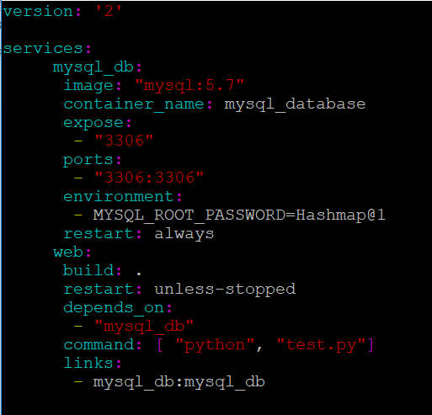

## Dockerfile

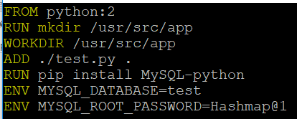

## Application files

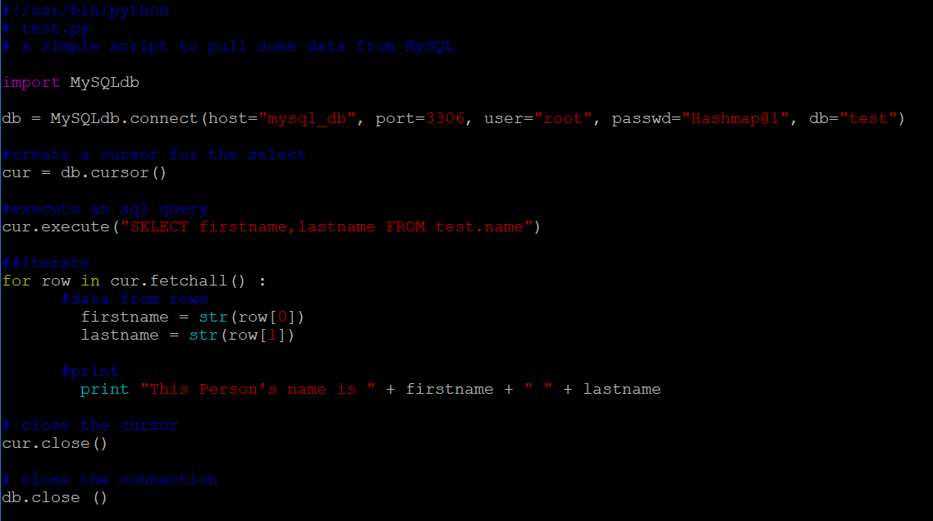

## Run Docker Compose

* Change the directory to the Docker compose files
* Run the command

Docker-compose up

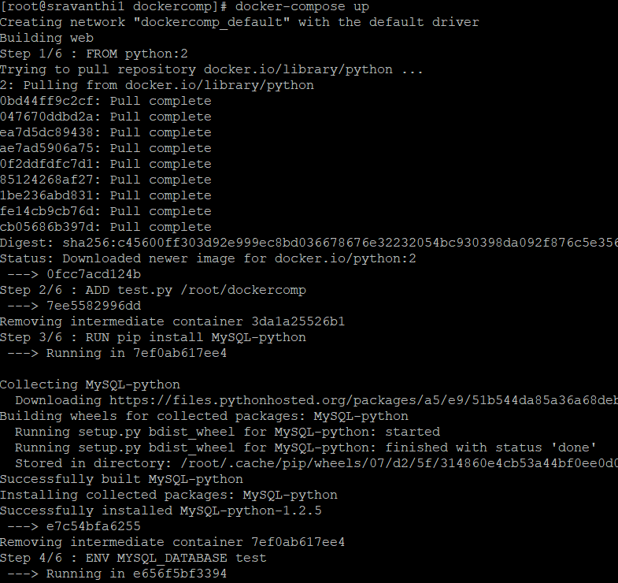

## List Docker Processes

Get to know the status of the docker container to be checked. Using command “docker ps” list the running containers and see what the possible statuses are. For example running container will have the status “Up”

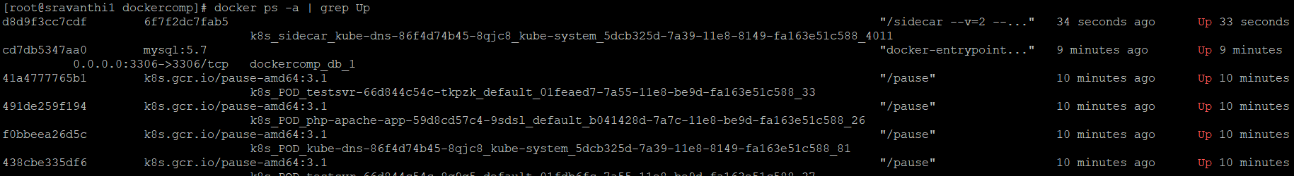

## Ssh to container

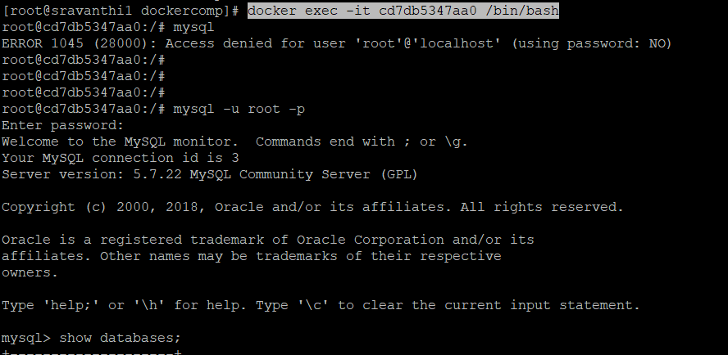

## Run appropriate commands inside container

For instance if the running container hosting the mysql database, use the following command to login to mysql

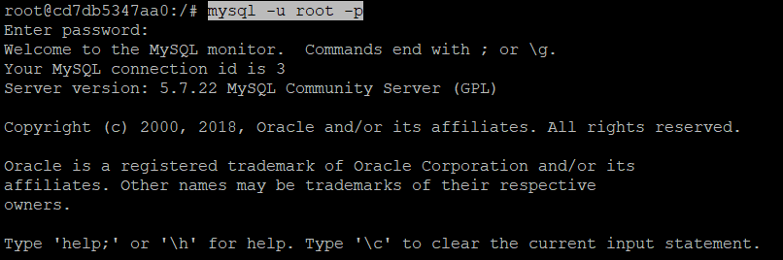

Create a test database and some sample tables in it for testing the database is working or not.

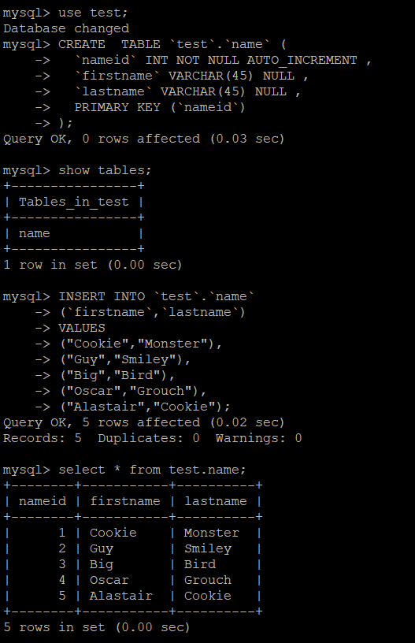

## Run the images with docker compose

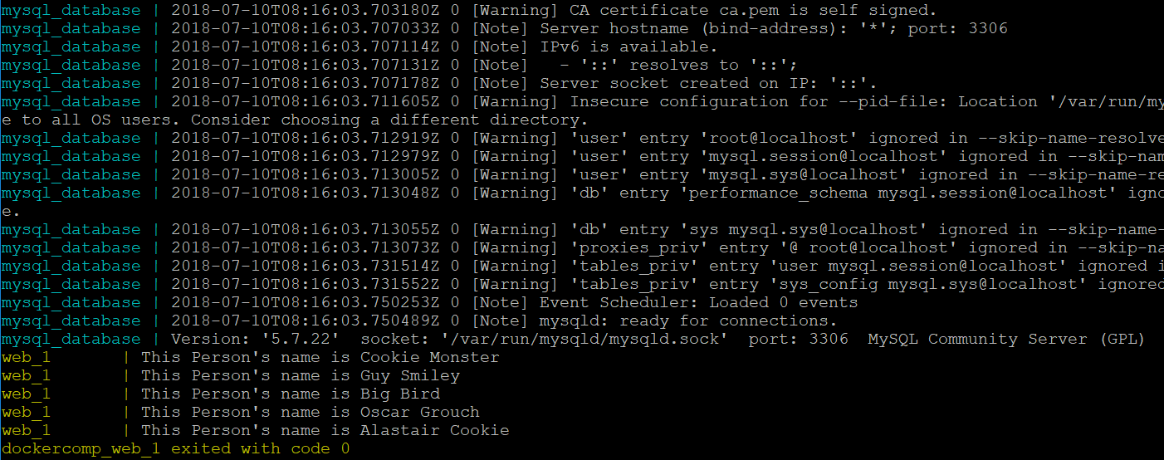

## Verify the functionality

